Test scripts
With Postman you can write and run tests for each request using the JavaScript language.
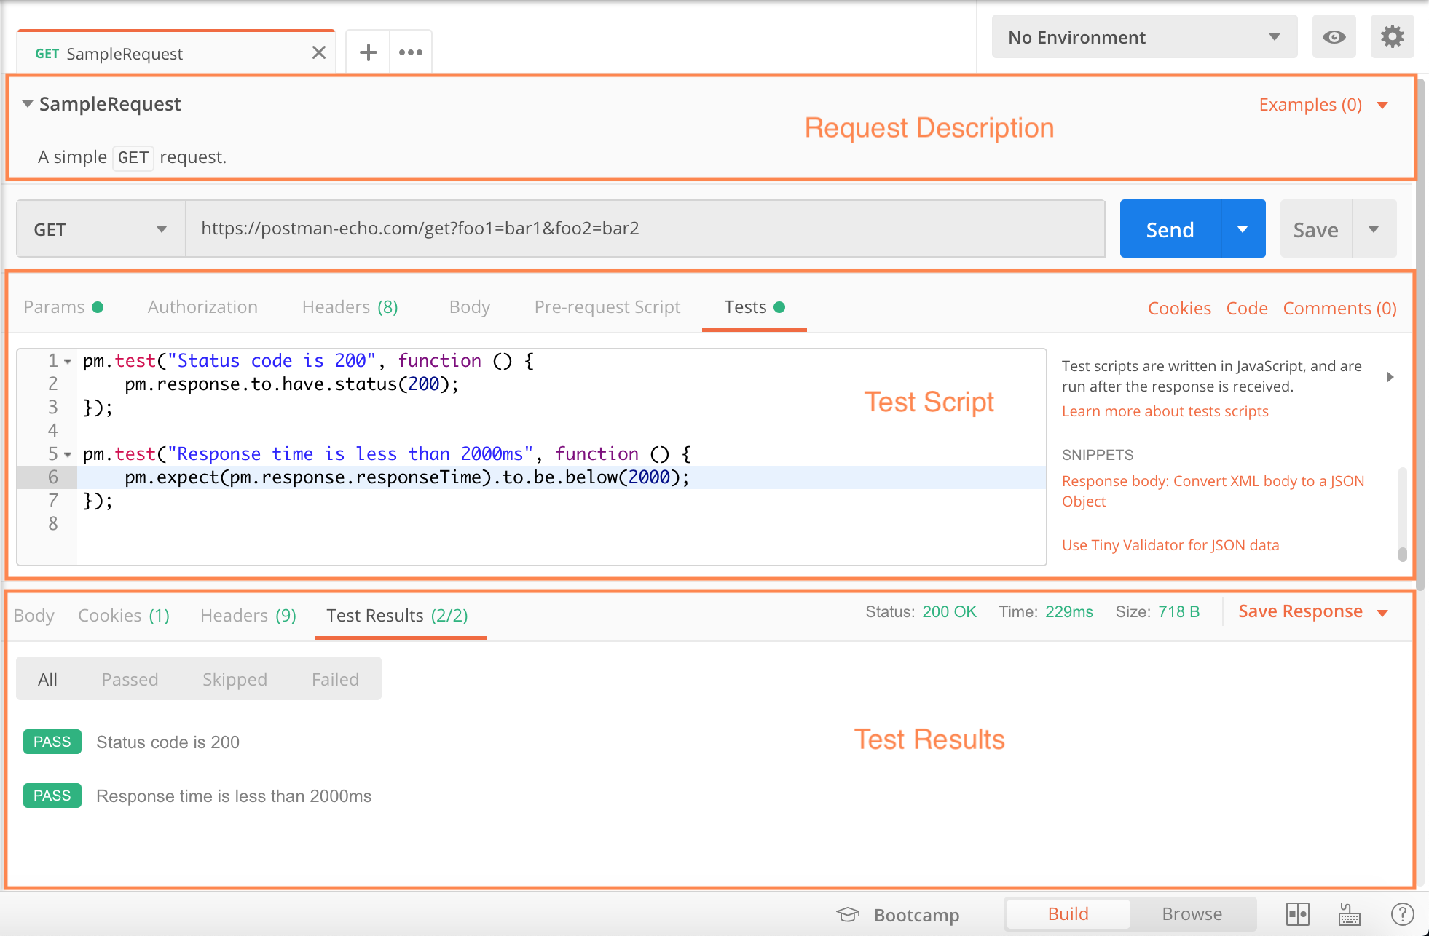

Writing Postman tests
A Postman test is essentially JavaScript code executed after the request is sent, allowing access to the pm.response object.
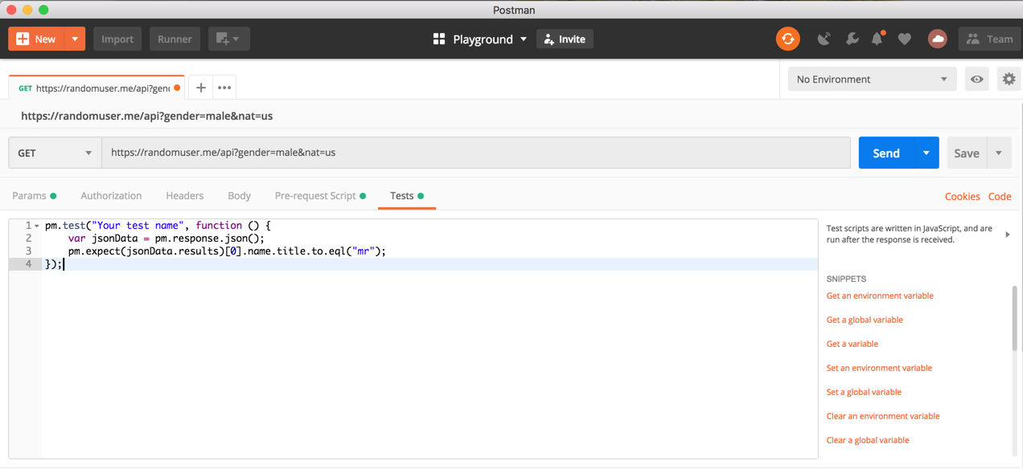
Here are some examples:
// example using pm.response.to.have
pm.test("response is ok", function () {
pm.response.to.have.status(200);
});

// example using pm.expect()
pm.test("environment to be production", function () {
pm.expect(pm.environment.get("env")).to.equal("production");
});

// example using response assertions
pm.test("response should be okay to process", function () {
pm.response.to.not.be.error;
pm.response.to.have.jsonBody("");
pm.response.to.not.have.jsonBody("error");
});

// example using pm.response.to.be*
pm.test("response must be valid and have a body", function () {
// assert that the status code is 200
pm.response.to.be.ok; // info, success, redirection, clientError, serverError, are other variants
// assert that the response has a valid JSON body
pm.response.to.be.withBody;
pm.response.to.be.json; // this assertion also checks if a body exists, so the above check is not needed
});
You can add as many tests as needed, depending on how many things you want to test for. Check out some examples of Postman tests.
Tests are saved as part of collection requests. This is perfect for both back-end and front-end developers to ensure that everything is working properly with the API. No more squinting through code trying to figure out what went wrong!

Sandbox
Postman tests run in a sandboxed environment, which is separate from the execution environment of the app. To check what is available in the test script sandbox, refer to the Sandbox documentation.

Snippets
While there are very few things to remember when writing tests, Postman tries to make the process easier by listing commonly used snippets next to the editor. You can select the snippet you want to add and the appropriate code populates in the test editor. This is a great way to quickly build test cases.
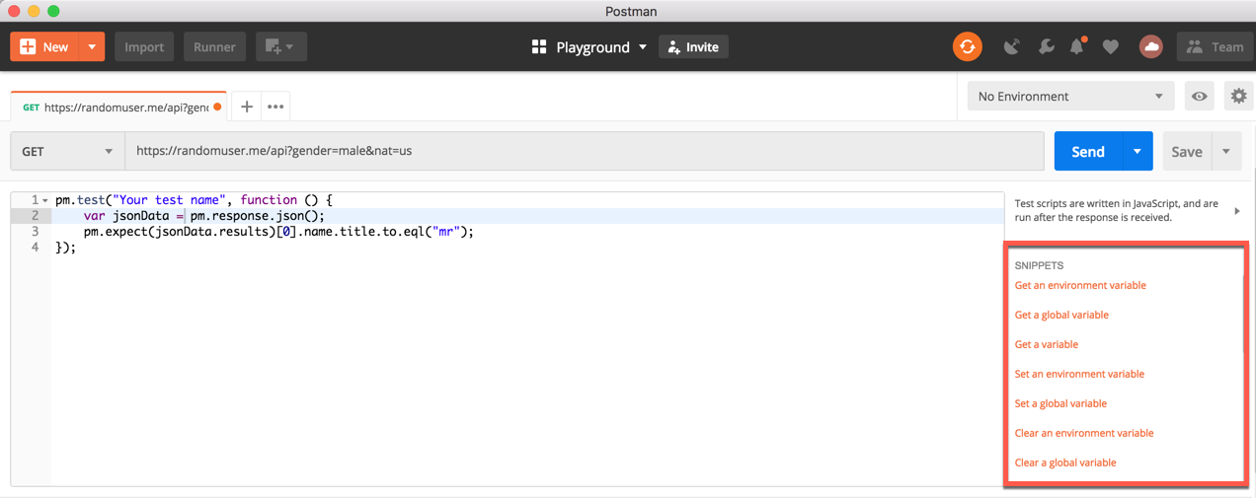

Viewing results
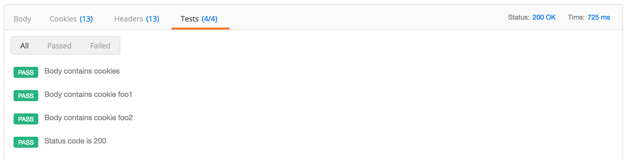
Postman runs tests every time you run a request. Of course, you can choose to not look at the test results!
Results are displayed in a Tests tab under the response viewer. The tab header shows how many tests passed, and the test results are listed here. If the test evaluates to true, the test passed.

Adding a test script to a collection or folder
You can add test scripts to a collection, a folder, or a single request within a collection. A test script associated with a collection will run after every request in the collection. A test script associated with a folder will run after every request in the folder. This allows you to reuse commonly executed tests after every request.
Collection and folder scripts can be updated in the collection or folder details respectively. Click on the ellipsis (...) next to the collection or folder name, and select “Edit” to open the modal. Select the Tests tab to add and update the scripts. You can also add collection scripts when initially creating the collection.
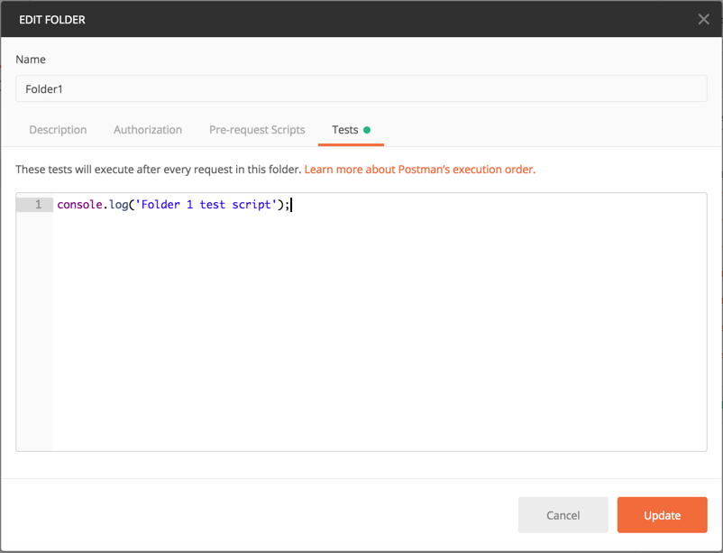Read more about the execution order of scripts.

